DECISIONS DELEGATED TO OFFICERS

Decision title: | Award of a contract to Ark Consulting to support a ‘Lessons Learnt’ review of QL implementation
Decision date: | 04.05.22
Source of delegation: | This decision was delegated to officers under Part 4.4 of the Council’s Constitution: all executive functions except those in Part 4.5, 4.6 and 4.7 are delegated to the officers in the senior management structure.
What decision was made? | To commission a ‘Lessons Learnt’ review and report from Ark Consulting - to be delivered against the specification for this work – relating to the implementation of the QL Housing system.  The expenditure for this commission is £9,900 + VAT and expenses.
Purpose: | The decision to proceed with the commission of services form Ark Consultancy will allow a ‘Lessons Learnt’ review and report relating to the implementation of the QL Housing system to be delivered.
Reasons: | The ‘Lessons Learnt’ review will support future service development and inform future projects.
Decision made by: | Stephen Gabriel, Executive Director for Communities and People
Other options considered: | Other suppliers were considered, but Ark Consultancy was considered best value for money.  The option to ‘do nothing’ was rejected, as this would mean that lessons would not be learned as a result of the significant issues which arose as a result of the implementation of the system.
Documents considered: | None
Key or Not Key: | Not Key
Wards significantly affected: | None
Declared conflict of interest: | None
This form was completed by:  Name & title:  Date: | Richard Wood  Strategy & Service Development Manager  24.04.22

Approval checklist

Approver | Name and job title | Date
Decision maker  The officer with authority to take the decision, either from a Cabinet delegation or in the Constitution. | 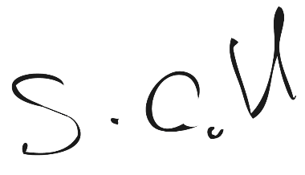  Stephen Gabriel  Executive Director – Communities and People | 4th May 2022

Consultee checklist

Consultees | Name and job title | Date
Senior officer | 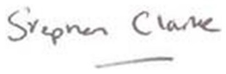  Stephen Clarke | 4th May 2022
Cabinet Member | Cllr Diko Walcott, Cabinet Member for Affordable Housing, Housing Security and Housing the Homeless | 4th May 2022

